Birth and Vaccination Report

Upon analysing vaccination data for the given states and comparing it with birth registrations we get the below data:

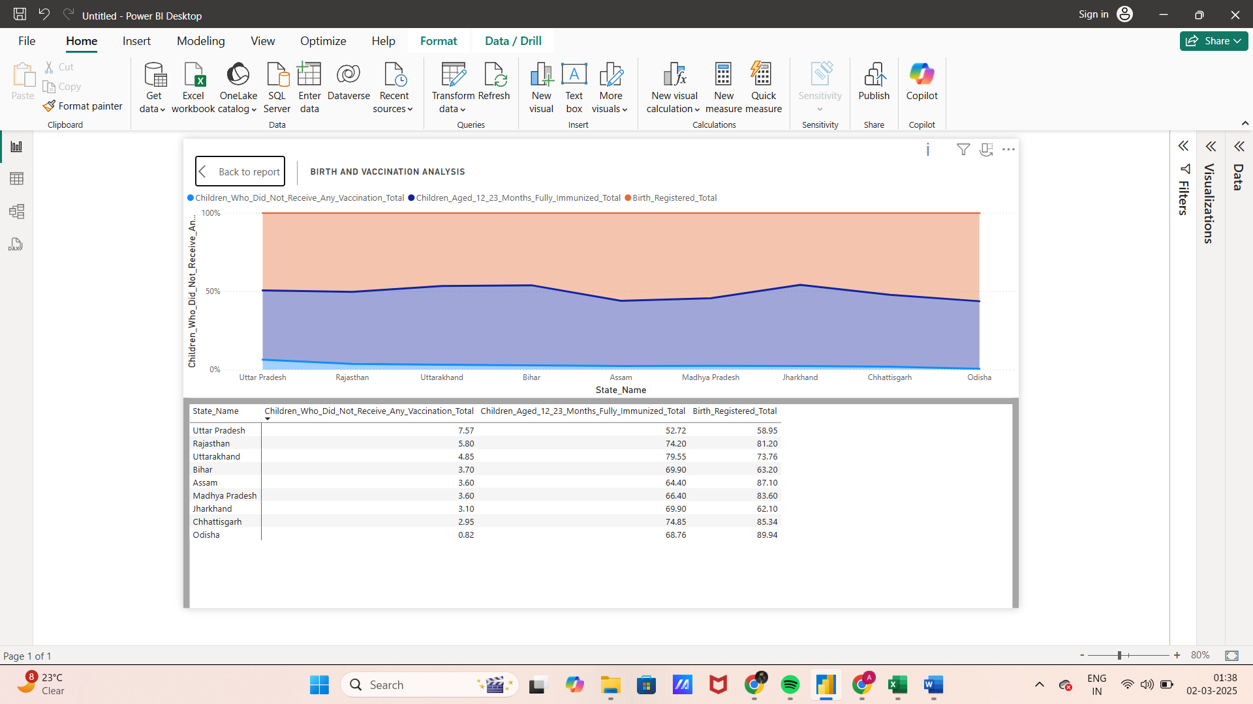

This data can be better explained through below graph:

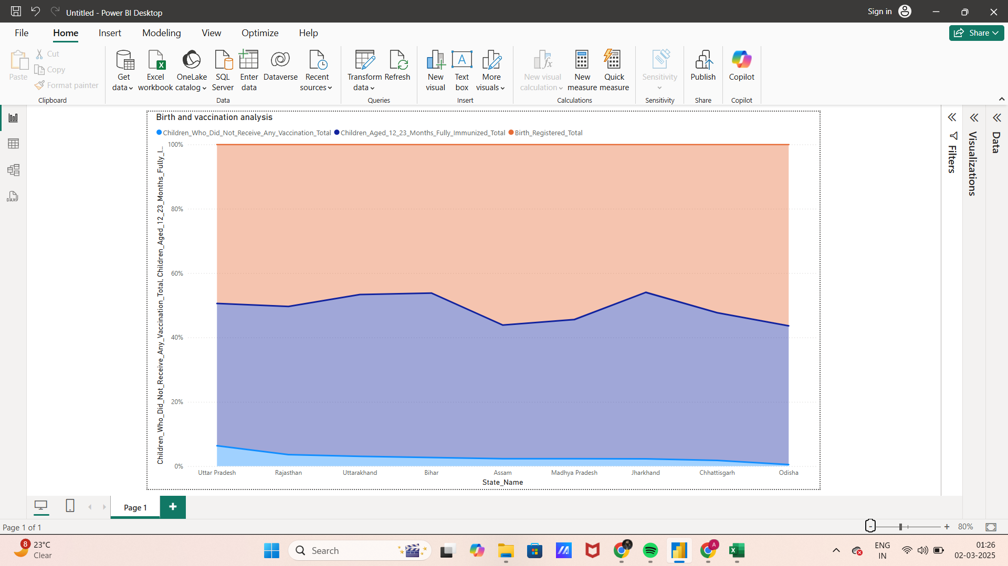

Observations in the graph:

1. Area below orange line is the total birth registrations.
2. Area between orange and violet line show the population that is partially vaccinated.
3. Area between violet line and blue line represents fully vaccinated population.
4. Are under blue line represents population which are not vaccinated.

Insights from the analysis:

1. All the given states have between 40-60% population that is partially vaccinated.
2. All the given states have between 0-10% population that is not vaccinated.
3. Jharkhand has most number of completely vaccinated population.
4. Assam has the least number of completely vaccinated population.
5. Uttar Pradesh has the most number of unvaccinated population.